Data Loader CLI Guidelines

Contents

Introduction 2

Prerequisites 2

Install Java Runtime Environment (JRE) Zulu version 2

Install Data loader on your computer 2

Setup the CLI Environments 2

Generate Secret Key & Security Token 2

Configuration file with Beans 3

Check Proxy Configuration 5

Start the data Loader CLI 5

Setup Global Variable (Optional) 6

Ressources 7

# Introduction

Specify the configuration, data sources, mappings, and actions in files. The CLI enables you to set up Data Loader for automated processing. It allows you to do Insert, Update, Upsert, Delete, Mass Delete, Export actions in one configuration file.

# Prerequisites

## Install Java Runtime Environnent (JRE) Zulu version

Data loader requires Java to work properly, you can download it (version Zulu LTS 17) here <https://cdn.azul.com/zulu/bin/zulu17.36.13-ca-jre17.0.4-win_x64.msi>

## Install Data loader on your computer

The Data loader application can be found in you Salesforce organization, under Setup Install the Data loader for Windows

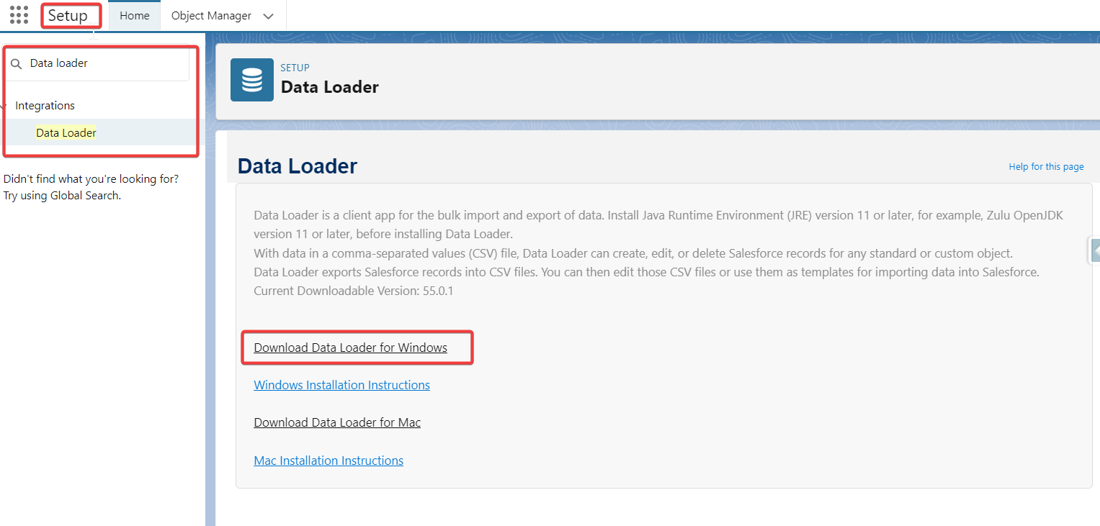

# Setup the CLI Environments

## Generate Secret Key & Security Token

To connect to your salesforce org, you need to generate a token based on your salesforce org password.

To do so we will use the encrypt.bat file to encrypt our password.

Open the CMD or PowerShell CLI:

Go to the encrypt file location (*[…]\dataloader\vXX.x.x\bin*), from here execute the following command to encrypt your salesforce password:

* encrypt.bat -k

*output:*

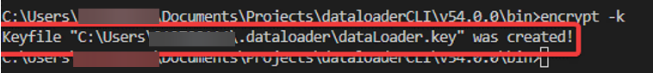

this will generate the security key and will give you the Location of it. Once this is done, encrypt your password by giving your password and the key location:

* encrypt.bat -e <mySFDCPassword> <locationOfDataloaderKey>

*output:*



Once the String is generated, copy, and keep it in a safe place. Now that you have your password setup, we can prepare the configuration file.

## Configuration file with Beans

Every time we call the data Loader, we are calling one Bean at a time. A Bean is a kind of profile that will execute a specific action. In this part we are going to configure one bean to see how it is built.

Here an example on how it looks like, we have 1 process-conf.xml file that contain all the beans.



The process-conf.xml base format look likes this:

<!DOCTYPE beans PUBLIC "-//SPRING//DTD BEAN//EN" "http://www.springframework.org/dtd/spring-beans.dtd">

<beans>

    [...]

</beans>

Under the beans tag we can have multiple bean tag that looks like this:

<bean id="extractUserStorylimit10" class="com.salesforce.dataloader.process.ProcessRunner" scope="prototype">

    <description>extractCCPMAttachments"</description>

    <property name="name" value="extractUserStorylimit10" />

    <property name="configOverrideMap">

        <map>

            <entry key="sfdc.debugMessages" value="false" />

            <entry key="sfdc.debugMessagesFile" value="../samples/status/extractUserStorylimit10Trace.log" />

            <entry key="sfdc.endpoint" value="https://test.salesforce.com" />

            <entry key="sfdc.username" value="mySFDCUsername" /> <!-- password specified below is invalid, please generate one using the encrypt.bat utility -->

            <entry key="sfdc.password" value="myGeneratedToken" />

            <entry key="process.encryptionKeyFile" value="C:\Users\212700114\.dataloader\dataLoader.key" />

            <entry key="sfdc.timeoutSecs" value="600" />

            <entry key="sfdc.entity" value="PM_User_Story__c" />

            <entry key="sfdc.extractionRequestSize" value="100" />

            <!-- <entry key="sfdc.useBulkApi" value="true" /> -->

            <entry key="sfdc.extractionSOQL" value="SELECT Name, Functional_Owner__c, As_Who__c, I_Want_To__c FROM PM_User_Story__c limit 10" />

            <entry key="process.operation" value="extract" />

            <entry key="process.mappingFile" value=".\v54.0.0\configs\Mapping\sfdcUserStoryMap.sdl" />

            <entry key="dataAccess.type" value="csvWrite" />

            <entry key="dataAccess.name" value=".\output-cli\extractUserStorylimit10.csv" />

        </map>

    </property>

</bean>

This bean contains all the information needed for a specific data loader action (In our case extract action).

Let’s see the important tags that we need to change.

|  |
| --- |
| <entry key="sfdc.endpoint" value="https://test.salesforce.com" />  Represent the connection URL of the target Org (in our case Dev Org)  Test  login |
| <entry key="sfdc.username" value="mySFDCUsername" />  The SFDC username |
| <entry key="sfdc.password" value="myGeneratedToken" />  The previously generated token |
| <entry key="process.encryptionKeyFile" value="C:\Users\Username\.dataloader\dataLoader.key" />  Location of the key may change based on your computer username |
| <entry key="sfdc.entity" value="PM_User_Story__c" />  The object in which you want to manipulate |
| <entry key="sfdc.extractionRequestSize" value="100" />  Batch Value for extraction (for loading you may need to use this tag : key="sfdc.loadBatchSize") |
| <entry key="sfdc.extractionSOQL" value="SELECT Id, […] FROM PM_User_Story__c limit 10" />  Represent your SOQL query |
| <entry key="process.operation" value="extract" />  The Type of operation: Extract |
| <entry key="dataAccess.type" value="csvWrite" />  Data Access type, we are writing a csv output here |
| <entry key="dataAccess.name" value=".\output-cli\extractUserStorylimit10.csv" />  Specify the location of the output |
|  |

## Check Proxy Configuration

There is 2 ways to setup the GE proxy configuration:

* from the data Loader GUI under settings

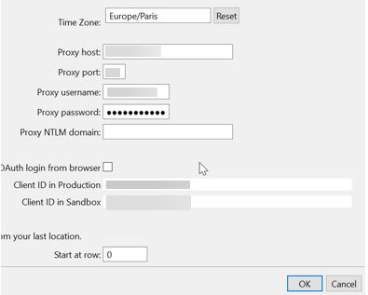

* inside the bean itself by adding the specific parameters for proxy configurations:

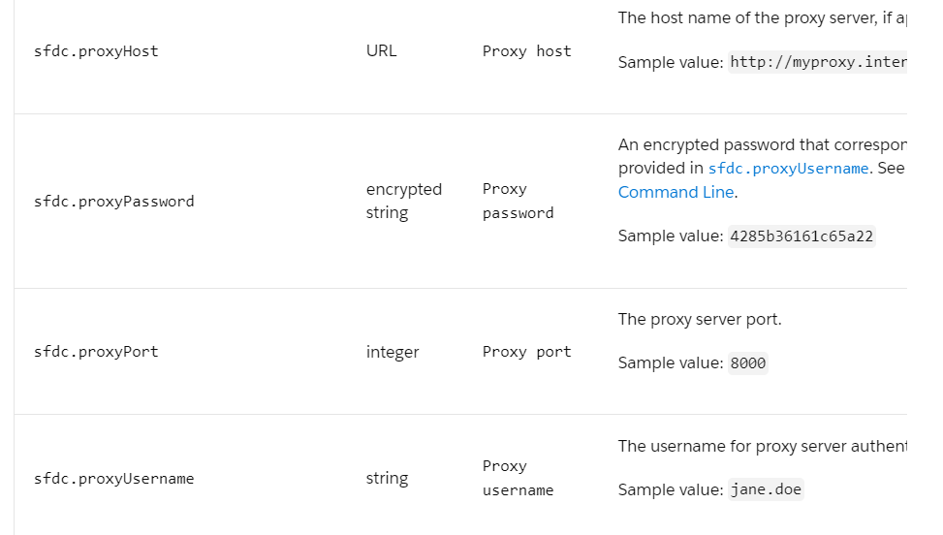

# Start the data Loader CLI

Open the Command Prompt (CMD or PowerShell) terminal and use the “process.bat” file to execute Data Loader command.

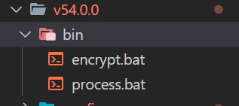

Go to the location of your process.bat file under terminal,



From here Execute the following command:

* process.bat [...]\configs\ <Name_Of_your_Bean>

the command has 2 parameters

[...]\configs\ => the location where is store the process-conf.xml

<Name_Of_your_Bean> => the Bean’s name that you specified in the process-conf.xml (example: extractUserStorylimit10)

## Setup Global Variable (Optional)

You can configure the data Loader by adding the bin folder to your environment variables:

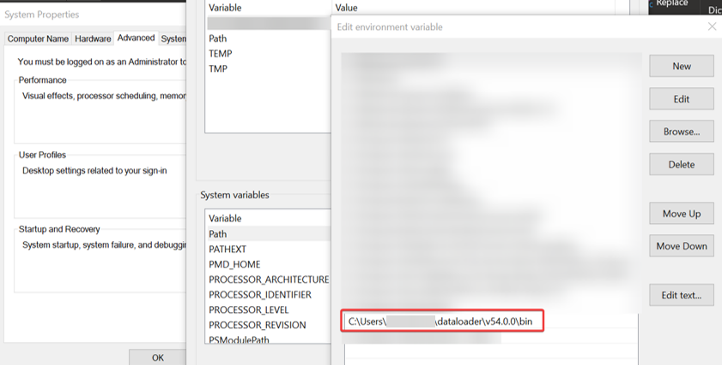

Like this no need to specify the path of the data loader command you can directly type:

* process

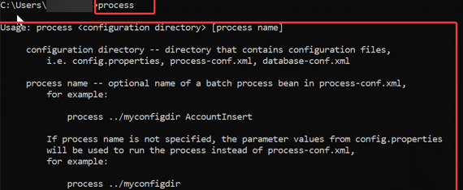

# Ressources

* [Install Data Loader on Windows | Data Loader Guide | Salesforce Developers](https://developer.salesforce.com/docs/atlas.en-us.dataLoader.meta/dataLoader/loader_install_windows.htm)
* [Data Loader Command Line Introduction | Data Loader Guide | Salesforce Developers](https://developer.salesforce.com/docs/atlas.en-us.dataLoader.meta/dataLoader/command_line_intro.htm)
* [Data Loader Process Configuration Parameters | Data Loader Guide | Salesforce Developers](https://developer.salesforce.com/docs/atlas.en-us.dataLoader.meta/dataLoader/loader_params.htm)
* [Step by Step Guide for using Salesforce Command Line Interface Data Loader - Salesforce Blog (sfdcpoint.com)](https://www.sfdcpoint.com/salesforce/step-by-step-guide-for-using-salesforce-command-line-interface-data-loader/#:~:text=Prerequisites%20for%20using%20CLI%20Data%20Loader%3A%20First%20of,environment%20Setup%20%E2%80%93%3E%20Data%20Management%20%E2%80%93%3E%20Data%20Loader.)